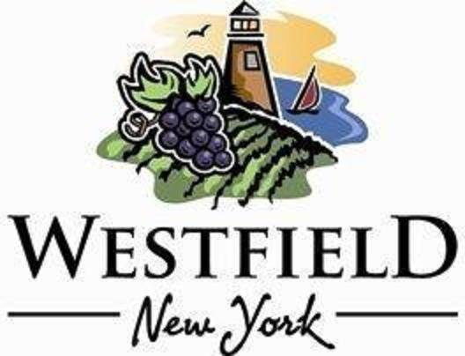

AGENDA
VILLAGE OF WESTFIELD
PLANNING BOARD

DATE: Tuesday, November 12th, 2024 PLACE: Eason Hall -North Room
TIME: 4:00 pm

- Calarco’s Sign

- Fire Department Digital Sign

- Mark Lancaster – Lancaster Foods LLC

- October 9th, 2024, Minutes review and approval

- Adjournment

