THE WESTFIELD VILLAGE REHAB PROGRAM

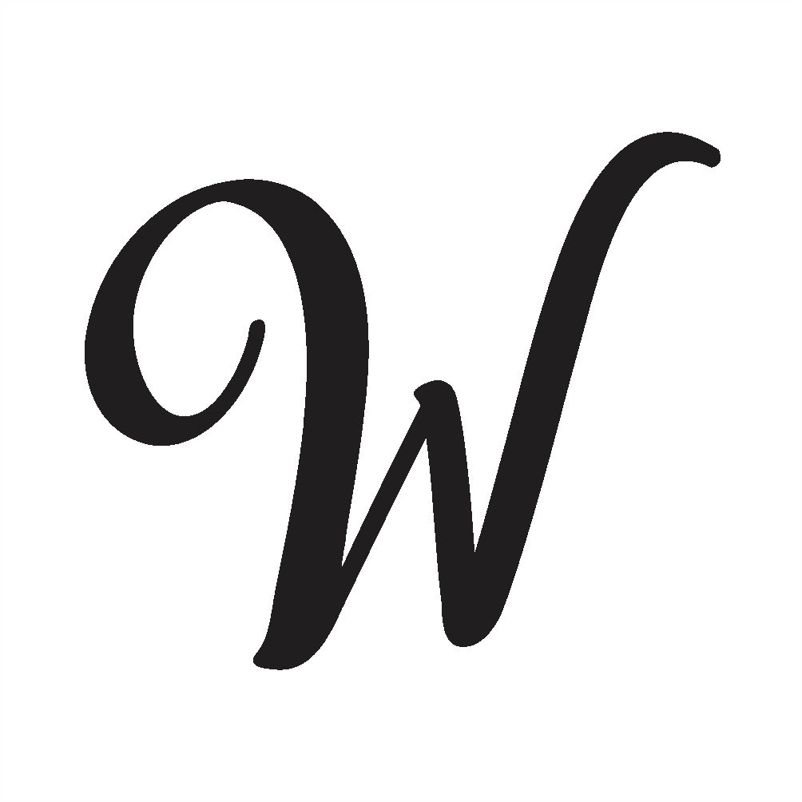
The Westfield Village Rehab Program is a grant awarded to the Village of Westfield by the New York State Office of Community Renewal (OCR) Community Development Block Grant (CDBG) program. The program is intended to provide financial assistance to low-income residents of the Village of Westfield whose homes are in need of repairs.
APPLICATIONS MUST BE RECEIVED AS SOON AS
POSSIBLE TO BE CONSIDERED FOR ASSISTANCE.

WHO IS ELIGIBLE?
The Westfield Village Rehab Program will assist approximately 7 owner-occupied properties. Commercial properties and rentals are not eligible. In order to be eligible, the residence must:
- be located in the Village of Westfield
- be in need of repairs
- be able to be repaired (brought up to basic health and safety standards) with the funds that are available, and
- be owned and occupied by residents who meet income guidelines. Income eligibility is based on the total income of all members of the household over age 18 from all sources (including social security, unemployment, retirement, etc.) before any taxes or deductions.
- If more than 7 complete applications are received, priority will be given to lowest income households and those with the least available cash assets first.
CURRENT INCOME GUIDELINES:
FAMILY SIZE | 1 Person | 2 People | 3 People | 4 People | 5 People | 6 People | 7 People | 8 People
MAXIMUM  ALLOWABLE  INCOME | $46,800 | $53,450 | $60,150 | $66,800 | $72,150 | $77,500 | $82,850 | $88,200

WHO WILL DECIDE IF I AM ELIGIBLE?
The Village of Westfield has contracted with Chautauqua Home Rehabilitation and Improvement Corporation (CHRIC), a countywide non-profit housing rehabilitation agency, to administer the funds. CHRIC has over 10+ years of experience administering state, federal, and private funds designed to assist low-income residents with home repairs. CHRIC will be responsible for verifying applicant eligibility and working with residents to assess the needs of eligible properties, complete work write-ups, and oversee work while it is underway. CHRIC can be contacted at:
Chautauqua Home Rehab & Improvement Corporation (CHRIC)
2 Academy St
Mayville, NY 14757
753-4650 (toll free: 661-7650)
WHAT TYPE OF WORK CAN BE DONE?
Any work that is necessary to bring the property up to basic health and safety standards may be eligible under the program, including work such as roofs, windows, doors, siding, furnaces, electrical, plumbing, septics, wells, etc. Grant funds cannot be used for remodeling or redecorating that is not necessary, including but not limited to, driveway repairs, lawn maintenance, and repairs to garages or barns.
Federal regulations also require that all properties that receive assistance through the CDBG program be assessed for lead-based paint hazards. Any lead-based paint hazards that are found must be addressed as part of the work that is completed.
The scope of work will be determined by the property owners’ needs and CHRIC's Housing Project Managers. All work will be done by insured, independent contractors that have been pre-qualified by CHRIC. Contracts will be awarded based on competitive bids.

WHEN WILL THE WORK GET DONE?
The process of administering state funding does not allow things to happen as quickly as people often wish they would. On average, the current time frame for CHRIC projects runs approximately 5-8 months from receiving an application until the work is complete.
When your application is received it needs to be reviewed for completeness and to determine your eligibility. Then a Project Manager will make an appointment to come to the property to inspect it with you. He or she will complete a work write-up, which you will have to sign indicating your approval. This write-up gets sent to contractors for their bids. The bids must be evaluated so that total cost and your cost share, if any, can be determined. When funds are in place, including your cost share (if any), the contractor will be issued a Notice to Proceed, at which time he will order materials for the job and schedule the work.
As you can see, each step is going to take a certain amount of time. Your involvement is required at almost every step, so you can help to avoid unnecessary delays by completing the things you need to do as quickly and thoroughly as possible.

WHAT WILL THE COST BE TO ME?
CHRIC will make every effort to cover as much of the cost as possible using CDBG funds and other CHRIC funds. In most cases, we can cover costs in full. If costs cannot be covered in full, you will be notified before contracts are prepared of how much cannot be covered. We will work with you to try to reduce costs if possible. If costs cannot be covered and you are unable to cover the shortfall, the project can be cancelled with no cost to you. However, we will make every effort to try to make sure that does not happen.

WHAT ARE THE REQUIREMENTS PLACED ON ME AS A RESULT OF RECEIVING THIS ASSISTANCE?
The OCR CDBG funds that are invested into the property are considered a deferred loan. A five-year declining lien will be placed on the property because of receiving assistance. The lien declines in equal amounts annually throughout the 5-year period. No payments must be made. The only time you may be responsible for repaying any money is if you sell the property within the five-year lien period. However, circumstances can be investigated after discussions with the State to assist in removing liens. The only real purpose of the lien, is to prevent misuse of public funds by people who may seek free money to invest into a property in order to sell it at a profit.

