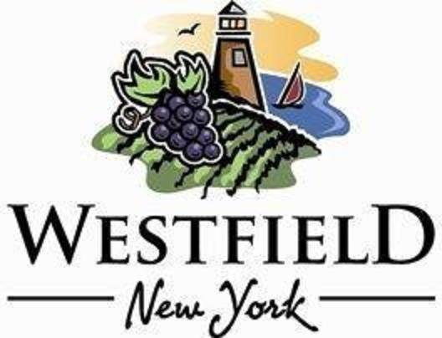

AGENDA
VILLAGE OF WESTFIELD
PLANNING BOARD

DATE: Wednesday, July 10th, 2024 PLACE: Eason Hall -North Room
TIME: 7:30am

- 7:30 AM: Open public hearing/take comments regarding the Special Use Permit application for 17 Academy Street Six Foot chain link fence (Irene Musante).

- Close Public Hearing for 17 Academy Street fence.

- Action on 17 Academy Street fence SUP

- Update on the Special Use Permit application for 96 W. Main Street 6’ fence (V. Mazza).

- Action on 96 W. Main Street fence SUP.

- Minutes review and approval – May 2024 Planning Board Meeting

- Adjournment

